Test Bank
Hardware and Behavioral AI



70 Multiple Choices
40 True or False questions
15 Fill in the Blanck
10 Essay Questions
10 Identification

- Multiple Choice

Instructions: Read each section carefully. Choose the best answer for each question.

1. What is the primary role of a CPU in a computer system?
a) Handle parallel computations for graphics
b) Interpret and execute the computer's demands
c) Perform specialized tensor operations
d) Recognize frequently encountered data patterns

2. Which processor is described as the "backbone of every computer"?
a) GPU
b) TPU
c) NPU
d) CPU

3. A GPU primarily works alongside the CPU to power the math for:
a) General-purpose logic and control flow
b) Graphics and digital visualization tasks
c) Low-latency inference on edge devices
d) Sequential task processing

4. Which processor is specifically designed and manufactured to perform machine learning tasks?
a) CPU
b) GPU
c) TPU
d) All of the above

5. An NPU helps an AI system learn by:
a) Executing complex branching logic
b) Recognizing frequently encountered data and accelerating computations
c) Rendering high-resolution graphics
d) Managing I/O operations for the system

6. The core principle of Behaviorist AI is inspired by:
a) Cognitive science
b) Computer engineering
c) Behaviorism in psychology
d) Linguistics

7. In the Behaviorist AI loop, what is the first step?
a) The agent performs an action.
b) The environment gives feedback.
c) The agent senses the environment.
d) The agent learns which actions are better.

8. How does an agent in a Behaviorist AI system learn?
a) By being pre-programmed with all possible outcomes.
b) By receiving rewards or penalties from the environment after actions.
c) By processing large datasets in a single batch.
d) By mimicking human brain structure directly.

9. Behaviorist AI forms the foundation of which machine learning paradigm?
a) Supervised Learning
b) Unsupervised Learning
c) Reinforcement Learning (RL)
d) Deep Learning

10. Which processor type is optimized for sequential tasks and branching logic?
a) GPU
b) TPU
c) NPU
d) CPU

11. GPUs, TPUs, and NPUs are all built for:
a) Sequential processing
b) Handling I/O operations
c) Massive parallelism
d) Low power consumption only

12. What type of mathematical operations are TPUs deeply specialized for?
a) Simple arithmetic
b) Tensor and matrix operations
c) Cryptographic functions
d) Random number generation

13. NPUs are built for neural network ______, with an emphasis on power efficiency.
a) Training
b) Inference
c) Design
d) Visualization

14. Which processor is considered more general but very effective for training large neural networks due to its flexibility?
a) CPU
b) GPU
c) TPU
d) NPU

15. The primary goal of an NPU's design is to achieve high performance with:
a) Maximum power consumption
b) Low energy use
c) High flexibility for non-AI tasks
d) Superior graphics rendering

16. For heavy AI tasks, which processor typically consumes more power compared to specialized chips?
a) NPU
b) TPU
c) CPU
d) GPU

17. Which processor is designed for high throughput, making it suitable for handling large AI models and heavy workloads in data centers?
a) CPU
b) GPU
c) TPU
d) NPU

18. A processor designed for **low latency** is ideal for:
a) Batch processing overnight
b) Real-time tasks requiring fast reaction times
c) General-purpose office applications
d) Complex sequential calculations

19. Where are NPUs most commonly integrated?
a) Into standalone desktop cards
b) Into system-on-chips (SoCs) in phones and edge devices
c) As the main processor in supercomputers
d) Exclusively in Google's cloud infrastructure

20. Which processor would you most likely use for everyday programs and OS tasks?
a) GPU
b) TPU
c) NPU
d) CPU

21. Training neural networks is a primary use case for which processor?
a) CPU
b) GPU
c) NPU
d) All are equally capable

22. Large-scale model training and inference in data centers, especially for deep learning, is the strength of the:
a) CPU
b) GPU
c) TPU
d) NPU

23. On-device AI inference in smartphones and IoT devices, where power and latency matter, is the main use case for the:
a) CPU
b) GPU
c) TPU
d) NPU

24. What is a key weakness of a CPU?
a) Low flexibility
b) Inefficiency at large-scale parallel tasks
c) High cost for simple tasks
d) Inability to handle logic

25. A key trade-off for using a GPU is its:
a) Lack of support in ML frameworks
b) High power consumption and lower efficiency for inference-only tasks
c) Inability to handle parallel tasks
d) Specialization only for tensor operations

26. TPUs are less flexible for:
a) Parallel computations
b) Non-ML tasks
c) Low-latency inference
d) Graphics rendering

27. A limitation of NPUs is that they are:
a) Too power-hungry for mobile devices
b) Not efficient for any AI tasks
c) Often specialized and limited to neural workload types
d) The best choice for all AI training

28. TPUs can be found in:
a) Supercomputers only
b) Coffee makers and alarm clocks
c) Smartphones exclusively
d) Desktop computers

29. The feedback an agent receives from the environment in Behaviorist AI can be a:
a) Reward only
b) Penalty only
c) New set of instructions
d) Reward or penalty

30. The learning loop in Behaviorist AI continues until:
a) The agent has explored all possible actions.
b) The agent learns to make better decisions.
c) The environment stops changing.
d) A predetermined time limit is reached.

31. Which processor is best suited for a task that requires immediate analysis of a live video feed on a smartphone?
a) CPU
b) GPU
c) TPU
d) NPU

32. Which processor would be the most efficient for retraining a massive language model in a cloud data center?
a) CPU
b) GPU
c) TPU
d) NPU

33. For running a word processing application, the most critical processor is the:
a) GPU
b) TPU
c) NPU
d) CPU

34. The ability of an NPU to "learn by recognizing frequently encountered data" most directly relates to its role in:
a) Training new models from scratch.
b) Performing inference on existing models.
c) Designing neural network architectures.
d) Rendering complex 3D environments.

35. "Inference" refers to:
a) The process of training a neural network.
b) Using a trained model to make predictions on new data.
c) The parallel execution of multiple threads.
d) The sequential processing of control logic.

36. The concept of an agent interacting with an environment is central to:
a) Central Processing
b) Graphics Processing
c) Behaviorist AI
d) Tensor Processing

37. Which of the following is a correct sequence in the Behaviorist AI loop?
a) Action -> Sense -> Feedback -> Learn
b) Sense -> Learn -> Action -> Feedback
c) Sense -> Action -> Feedback -> Learn
d) Learn -> Feedback -> Action -> Sense

38. A key strength of a TPU over a GPU is its:
a) Superior ability to handle general-purpose tasks.
b) Higher efficiency for specific tensor workloads.
c) Lower cost for consumer-grade hardware.
d) Better performance in graphic rendering.

39. A key strength of an NPU over a TPU is its:
a) Superior throughput for data center workloads.
b) Ability to handle non-ML tasks effectively.
c) Low latency and energy efficiency for edge inference.
d) Flexibility in training various model architectures.

40. Which processor type is characterized by its focus on "high throughput" for "batch AI workloads"?
a) CPU
b) GPU
c) TPU
d) NPU

41. The statement "NPUs rely on inference instead of training" means they are optimized for:
a) Learning new patterns from large, unlabeled datasets.
b) The deployment and use of already-trained models.
c) The initial phase of adjusting model weights.
d) Performing complex branching logic operations.

42. In a comparison of power efficiency for a specific AI task, the order from most to least efficient would likely be:
a) NPU, TPU, GPU, CPU
b) CPU, GPU, TPU, NPU
c) GPU, CPU, NPU, TPU
d) TPU, NPU, CPU, GPU

43. The "reward or penalty" in Behaviorist AI directly influences:
a) The speed of the CPU.
b) The agent's future action selection.
c) The complexity of the environment.
d) The design of the neural network hardware.

44. Which processor is most likely to be part of a cloud infrastructure like Google's AI platform?
a) CPU
b) GPU
c) TPU
d) NPU

45. The "loop" in Behaviorist AI is iterative, meaning it:
a) Happens only once.
b) Repeats continuously.
c) Is controlled by the GPU.
d) Requires a TPU to function.

46. Which of the following is NOT a typical characteristic of an NPU?
a) Low power consumption
b) High latency
c) Optimized for inference
d) Integrated into SoCs

47. The "general use case" for a CPU is best described as:
a) Parallel computations
b) Specialized tensor operations
c) General-purpose processing
d) Neural network inference

48. Which processor's strength is its flexibility in handling diverse tasks?
a) GPU
b) TPU
c) NPU
d) CPU

49. For a task that requires performing millions of similar calculations simultaneously (e.g., pixel manipulation), the best processor would be a:
a) CPU
b) GPU
c) TPU
d) NPU
e) Both b and c
f) Both b, c, and d

50. The document suggests that TPUs are less common in:
a) Data centers
b) Cloud platforms
c) Consumer edge devices like coffee makers
d) AI research labs

51. The learning process in Behaviorist AI is fundamentally:
a) Supervised
b) Unsupervised
c) Reinforcement-based
d) Pre-programmed

52. Which component is responsible for providing feedback to the agent in the Behaviorist AI model?
a) The Agent itself
b) The CPU
c) The Environment
d) The Programmer

53. The primary difference between a GPU and a TPU is the TPU's:
a) Higher level of general-purpose flexibility.
b) Superior performance in graphics rendering.
c) Deep specialization for tensor operations.
d) Lower cost and wider availability.

54. A system-on-chip (SoC) in a modern smartphone most likely contains a:
a) CPU, GPU, and NPU
b) CPU and TPU only
c) TPU and NPU only
d) GPU and TPU only

55. The term "agent" in Behaviorist AI refers to:
a) The environment the AI operates in.
b) The AI system that is learning and acting.
c) The processor running the AI model.
d) The reward function.

56. Which processor is most likely to be "the bottleneck" in a system trying to run a complex AI model in real-time on a desktop computer without specialized hardware?
a) GPU
b) TPU
c) NPU
d) CPU

57. The evolution from CPU to GPU to TPU/NPU demonstrates a trend towards:
a) Increased general-purpose functionality.
b) Higher clock speeds for sequential tasks.
c) Greater specialization for specific computational workloads.
d) Reduced need for parallel processing.

58. In the table from the second document, which processor is listed as having the weakness "Inefficient at large scale parallel tasks"?
a) GPU
b) TPU
c) NPU
d) CPU

59. According to the second document, a key strength of GPUs is that they are:
a) Very efficient for tensor workloads.
b) Low latency and energy-efficient.
c) Good at parallel tasks and widely supported.
d) Flexible and handle diverse tasks.

60. The concept of "accelerating computations while using less energy" is a defining feature of the:
a) CPU
b) GPU
c) TPU
d) NPU

61. Which statement best describes the relationship between Behaviorist AI and Reinforcement Learning (RL)?
a) They are the same thing.
b) Behaviorist AI is a subset of RL.
c) RL is a computational implementation of the principles of Behaviorist AI.
d) They are competing and unrelated approaches.

62. The "control flow" of a program is primarily managed by the:
a) GPU
b) TPU
c) NPU
d) CPU

63. Which processor would be most critical for achieving high frames-per-second in a video game?
a) CPU
b) GPU
c) TPU
d) NPU

64. The document mentions that NPUs help AI systems learn by recognizing patterns. This "learning" in the context of an NPU is best described as:
a) Adjusting the model's weights during training.
b) Efficiently applying a pre-trained model to new data.
c) Creating a new model architecture.
d) Labeling a large dataset.

65. The final step in the Behaviorist AI loop is:
a) The agent senses the environment.
b) The agent performs an action.
c) The environment gives feedback.
d) The agent learns which actions lead to better outcomes.

66. For a company deploying a face-unlock feature on its smartphones, the most important processor to design for is the:
a) CPU
b) GPU
c) TPU
d) NPU

67. A "tensor" is a fundamental data structure in:
a) General-purpose computing
b) Graphics rendering
c) Deep learning
d) Operating system design

68. The idea that learning is a result of interaction with the environment is a core tenet of:
a) Cognitive psychology
b) Behaviorism
c) Structuralism
d) Functionalism

69. Which processor is most specialized and thus has the most limited range of applications outside its domain?
a) CPU
b) GPU
c) TPU
d) (Both b and c are highly specialized)

70. The foundational idea that Behaviorist AI is based on "how agents behave and learn" emphasizes the importance of:
a) Internal mental states
b) Observable actions and outcomes
c) Pre-existing knowledge
d) Symbolic representation

- True Or False Questions

Instructions: Indicate whether the statement is true (T) or false (F).

- ( ) A CPU is specialized for parallel computations.

- ( ) A GPU's original purpose was for graphics rendering.

- ( ) TPUs are general-purpose processors like CPUs.

- ( ) NPUs are designed to be highly power-efficient.

- ( ) Behaviorist AI is inspired by cognitive psychology.

- ( ) In Behaviorist AI, the agent learns solely from a pre-loaded dataset.

- ( ) The environment provides feedback to the agent in the form of rewards or penalties.

- ( ) Reinforcement Learning is unrelated to Behaviorist AI.

- ( ) CPUs are optimized for handling many threads simultaneously.

- ( ) TPUs are specialized for tensor and matrix operations.

- ( ) NPUs are primarily used for training large neural networks.

- ( ) GPUs are inefficient for all AI-related tasks.

- ( ) Latency refers to the total amount of work done over time.

- ( ) NPUs are designed for low latency.

- ( ) TPUs are designed for high throughput.

- ( ) NPUs are commonly found as standalone components in desktop computers.

- ( ) CPUs are a good choice for the core logic of an operating system.

- ( ) GPUs are not suitable for training neural networks.

- ( ) TPUs are commonly used for on-device inference in smartphones.

- ( ) A key weakness of CPUs is their inefficiency in large-scale parallel tasks.

- ( ) GPUs have no significant weaknesses compared to other processors.

- ( ) TPUs are highly flexible for non-ML tasks.

- ( ) NPUs are limited to specific types of neural workloads.

- ( ) According to the first document, TPUs can be part of machine frameworks.

- ( ) The Behaviorist AI loop ends after a single interaction.

- ( ) The agent's actions can change the state of the environment.

- ( ) "Inference" and "Training" refer to the same process in AI.

- ( ) A SoC (System-on-Chip) can integrate multiple processor types like CPU, GPU, and NPU.

- ( ) Parallelism is a key strength of modern CPUs over GPUs.

- ( ) The primary use case for an NPU is everyday programs like web browsers.

- ( ) Behaviorist AI requires that the agent has a full internal model of the environment.

- ( ) Rewards in Behaviorist AI reinforce the actions that led to them.

- ( ) All processors (CPU, GPU, TPU, NPU) are equally capable of running a word processor.

- ( ) Google is a primary developer and user of TPUs.

- ( ) The term "agent" in Behaviorist AI could refer to a software program or a robot.

- ( ) The first step for an AI agent is always to perform a random action.

- ( ) Power efficiency is a minor concern when choosing hardware for data center AI training.

- ( ) The learning process in Behaviorist AI is static and does not improve over time.

- ( ) A coffee maker with a TPU is an example of an edge device.

- ( ) The conclusion of the first document states that Behaviorist AI is the foundation of Supervised Learning.

- Fill In the Blanck

Instructions: Complete the following sentences with the correct term.

Inference | Tensor | Behaviorism | Graphics | Inference
Energy | CPU | Reinforcement | Feedback | Decisions
Parallelism | Throughput | TPUs | Parallel | SoCs

- The ________ is responsible for interpreting and executing a computer's demands.

- A ________ Processing Unit works alongside the CPU to handle math for graphics.

- ________ are integral to machine learning workloads and can be found in devices like coffee makers.

- An NPU relies on ________ to help an AI system learn by recognizing data patterns.

- The idea that learning occurs through interaction with the environment and reinforcement is drawn from ________ in psychology.

- In the Behaviorist AI loop, the environment gives ________ after an action is performed.

- Behaviorist AI forms the foundation of ________ Learning.

- Processors like GPU, TPU, and NPU are built for massive ________.

- TPUs are deeply specialized for ________ operations.

- NPUs are optimized for neural network ________, not training.

- A key design goal for NPUs is high performance with low ________ use.

- TPUs are designed for high ________, making them good for batch workloads.

- NPUs are often integrated into ________ in mobile devices.

- A CPU's weakness is its inefficiency at large-scale ________ tasks.

- The learning loop in Behaviorist AI continues until the agent learns to make better ________.

- Essay Questions

Instructions: Answer the following questions in detail.

- Compare and contrast the architecture of CPUs and GPUs in terms of control flow, parallelism, and instruction handling. Explain how these differences make each processor type suitable for specific tasks such as operating system management (CPU) and neural network training (GPU)

- Specialization in AI Hardware: Trace the evolution from CPUs to GPUs to TPUs/NPUs. Discuss why this trend towards specialization is happening, using the concepts of efficiency, parallelism, and specific workload demands.

- Behaviorist AI Principles: Describe the core cycle of learning in Behaviorist AI. Use the steps provided in the document to explain how an agent improves its decision-making over time through interaction with its environment.

- Hardware Selection: You are designing a new smartphone. Justify the inclusion of an NPU in the System-on-Chip (SoC). Contrast its intended role with that of the CPU and GPU also present in the SoC.

- TPU vs. NPU: While both TPUs and NPUs are AI accelerators, they are optimized for different scenarios. Distinguish between them based on their primary use case, design focus (latency vs. throughput), and typical deployment environment.

- From Theory to Practice: Explain how the principles of Behaviorist AI, are computationally realized in Reinforcement Learning. What is the role of the "reward/penalty" signal in this implementation?

- Trade-offs in Design: Discuss the major trade-offs involved in processor design. Why can't a single processor type be the best at everything?

- Real-world Application: The first document mentions TPUs in coffee makers. Propose a plausible scenario for how a Behaviorist AI agent, running on specialized hardware like a TPU or NPU, could be used to improve the functionality of a smart coffee maker.

- System Integration: In a modern data center running AI services, all four processor types (CPU, GPU, TPU, NPU) might be present. Describe a hypothetical workflow for training and deploying an AI model, explaining the likely role of each processor type in the pipeline.

- The Future of Learning: Based on the description of Behaviorist AI, argue for its potential and its limitations as an approach to creating general artificial intelligence. How does its focus on interaction and feedback shape what it can and cannot learn?

- Identification

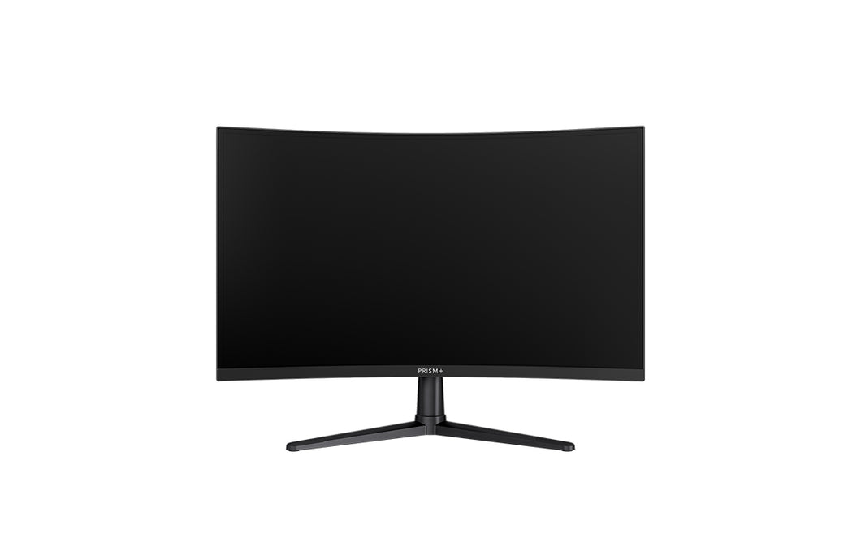

- ______________

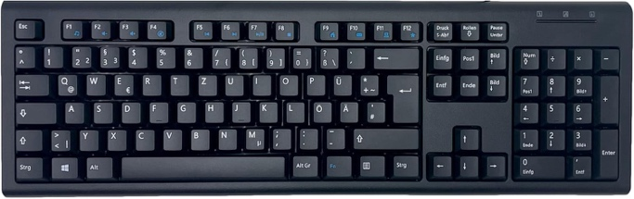

- ______________

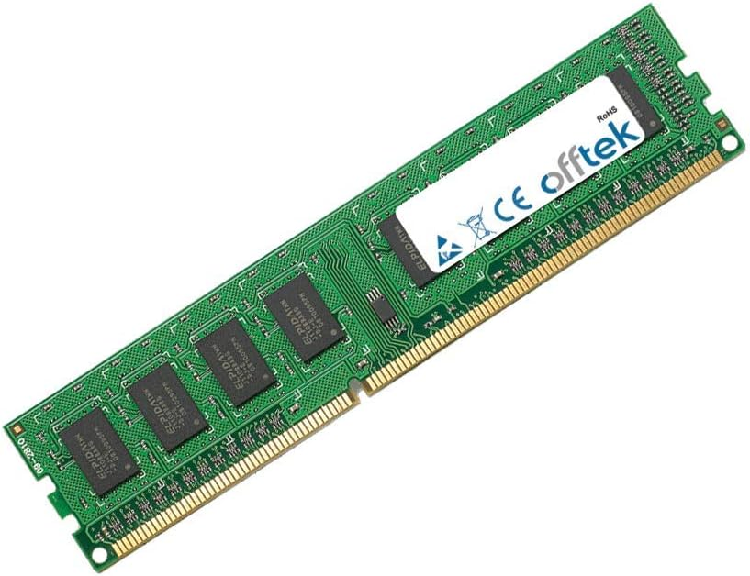

- ______________

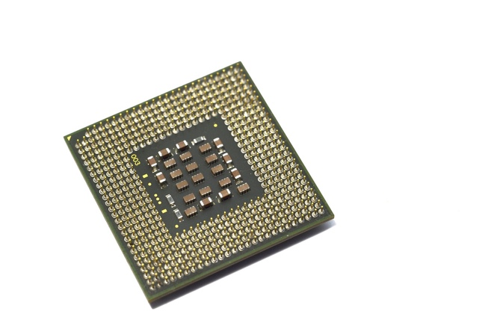

- ______________

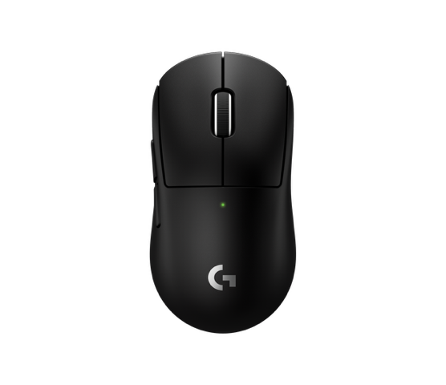

- ______________

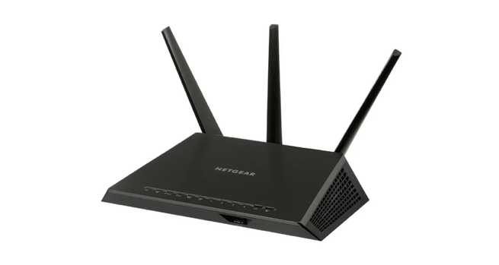

- ______________

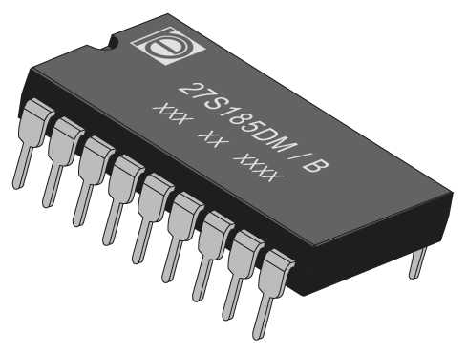

- ______________

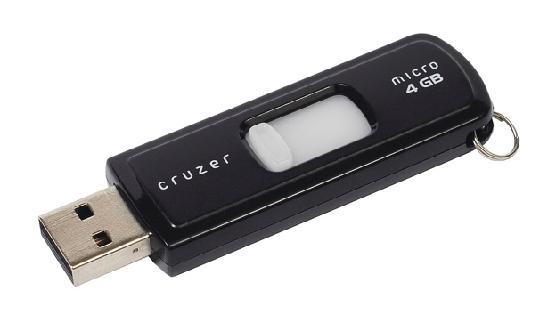

- ______________

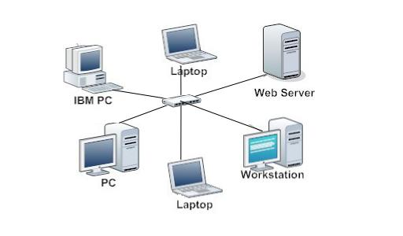

- ______________

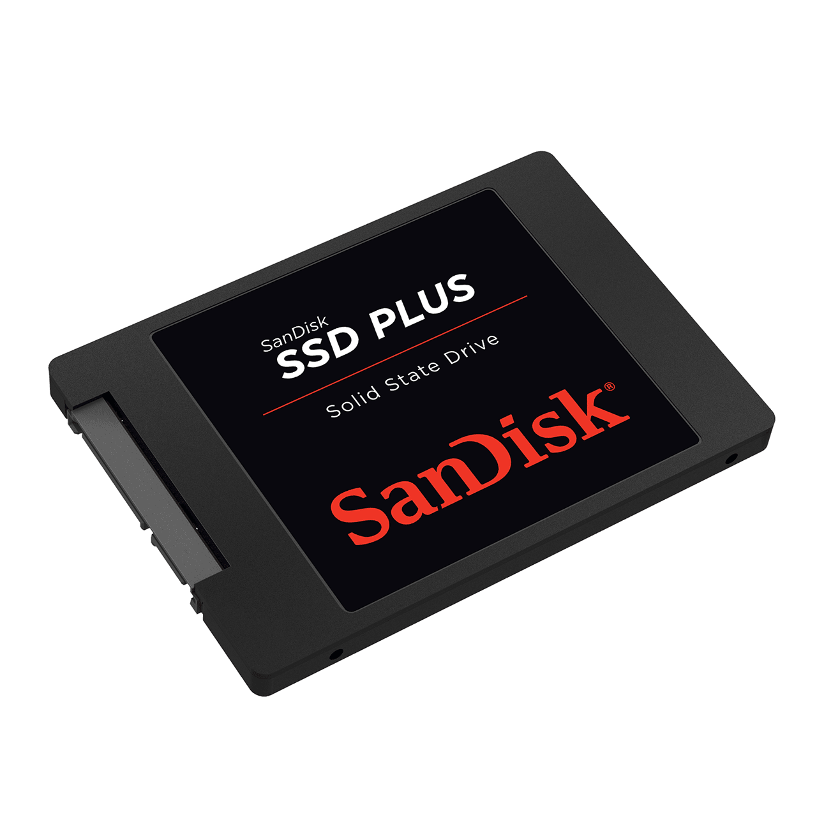

10.______________

Answers

Answers to Multiple Choice Questions

1. b) Interpret and execute the computer's demands
2. d) CPU
3. b) Graphics and digital visualization tasks
4. c) TPU
5. b) Recognizing frequently encountered data and accelerating computations
6. c) Behaviorism in psychology
7. c) The agent senses the environment.
8. b) By receiving rewards or penalties from the environment after actions.
9. c) Reinforcement Learning (RL)
10. d) CPU
11. c) Massive parallelism
12. b) Tensor and matrix operations
13. b) Inference
14. b) GPU
15. b) Low energy use
16. c) CPU
17. c) TPU
18. b) Real-time tasks requiring fast reaction times
19. b) Into system-on-chips (SoCs) in phones and edge devices
20. d) CPU
21. b) GPU
22. c) TPU
23. d) NPU
24. b) Inefficiency at large-scale parallel tasks
25. b) High power consumption and lower efficiency for inference-only tasks
26. b) Non-ML tasks
27. c) Often specialized and limited to neural workload types
28. b) Coffee makers and alarm clocks
29. d) Reward or penalty
30. b) The agent learns to make better decisions.
31. d) NPU
32. c) TPU
33. d) CPU
34. b) Performing inference on existing models.
35. b) Using a trained model to make predictions on new data.
36. c) Behaviorist AI
37. c) Sense -> Action -> Feedback -> Learn
38. b) Higher efficiency for specific tensor workloads.
39. c) Low latency and energy efficiency for edge inference.
40. c) TPU
41. b) The deployment and use of already-trained models.
42. a) NPU, TPU, GPU, CPU
43. b) The agent's future action selection.
44. c) TPU
45. b) Repeats continuously.
46. b) High latency
47. c) General-purpose processing
48. d) CPU
49. f) Both b, c, and d (GPU, TPU, NPU)
50. c) Consumer edge devices like coffee makers
51. c) Reinforcement-based
52. c) The Environment
53. c) Deep specialization for tensor operations.
54. a) CPU, GPU, and NPU
55. b) The AI system that is learning and acting.
56. d) CPU
57. c) Greater specialization for specific computational workloads.
58. d) CPU
59. c) Good at parallel tasks and widely supported.
60. d) NPU
61. c) RL is a computational implementation of the principles of Behaviorist AI.
62. d) CPU
63. b) GPU
64. b) Efficiently applying a pre-trained model to new data.
65. d) The agent learns which actions lead to better outcomes.
66. d) NPU
67. c) Deep learning
68. b) Behaviorism
69. c) TPU
70. b) Observable actions and outcomes

Answers to True or False Questions

1. ( F ) A CPU is specialized for parallel computations.
2. ( T ) A GPU's original purpose was for graphics rendering.
3. ( F ) TPUs are general-purpose processors like CPUs.
4. ( T ) NPUs are designed to be highly power-efficient.
5. ( F ) Behaviorist AI is inspired by cognitive psychology.
6. ( F ) In Behaviorist AI, the agent learns solely from a pre-loaded dataset.
7. ( T ) The environment provides feedback to the agent in the form of rewards or penalties.
8. ( F ) Reinforcement Learning is unrelated to Behaviorist AI.
9. ( F ) CPUs are optimized for handling many threads simultaneously.
10. ( T ) TPUs are specialized for tensor and matrix operations.
11. ( F ) NPUs are primarily used for training large neural networks.
12. ( F ) GPUs are inefficient for all AI-related tasks.
13. ( F ) Latency refers to the total amount of work done over time. (Throughput)
14. ( T ) NPUs are designed for low latency.
15. ( T ) TPUs are designed for high throughput.
16. ( F ) NPUs are commonly found as standalone components in desktop computers.
17. ( T ) CPUs are a good choice for the core logic of an operating system.
18. ( F ) GPUs are not suitable for training neural networks.
19. ( F ) TPUs are commonly used for on-device inference in smartphones.
20. ( T ) A key weakness of CPUs is their inefficiency in large-scale parallel tasks.
21. ( F ) GPUs have no significant weaknesses compared to other processors.
22. ( F ) TPUs are highly flexible for non-ML tasks.
23. ( T ) NPUs are limited to specific types of neural workloads.
24. ( T ) According to the first document, TPUs can be part of machine frameworks.
25. ( F ) The Behaviorist AI loop ends after a single interaction.
26. ( T ) The agent's actions can change the state of the environment.
27. ( F ) "Inference" and "Training" refer to the same process in AI.
28. ( T ) A SoC (System-on-Chip) can integrate multiple processor types like CPU, GPU, and NPU.
29. ( F ) Parallelism is a key strength of modern CPUs over GPUs.
30. ( F ) The primary use case for an NPU is everyday programs like web browsers.
31. ( F ) Behaviorist AI requires that the agent has a full internal model of the environment.
32. ( T ) Rewards in Behaviorist AI reinforce the actions that led to them.
33. ( F ) All processors (CPU, GPU, TPU, NPU) are equally capable of running a word processor.
34. ( T ) Google is a primary developer and user of TPUs.
35. ( T ) The term "agent" in Behaviorist AI could refer to a software program or a robot.
36. ( F ) The first step for an AI agent is always to perform a random action.
37. ( F ) Power efficiency is a minor concern when choosing hardware for data center AI training.
38. ( F ) The learning process in Behaviorist AI is static and does not improve over time.
39. ( T ) A coffee maker with a TPU is an example of an edge device.
40. ( F ) The conclusion of the first document states that Behaviorist AI is the foundation of Supervised Learning.

Answers to Fill in the Blank

1. CPU
2. Graphics
3. TPUs (Tensor Processing Units)
4. inference
5. behaviorism
6. feedback
7. Reinforcement
8. parallelism
9. tensor
10. inference
11. energy
12. throughput
13. Systems-on-Chip (SoCs)
14. parallel
15. decisions

Answers to Essay Questions
1. CPU vs. GPU
CPUs are optimized for sequential, general-purpose tasks with complex control logic, while GPUs are optimized for massively parallel numerical computations. CPUs excel at decision-heavy workloads; GPUs at repetitive data-heavy workloads like graphics or AI matrix math.
2. Specialization in AI Hardware
The move from CPU → GPU → TPU/NPU reflects increasing task specialization. CPUs offer flexibility, GPUs offer parallelism, and TPUs/NPUs offer hardware-accelerated AI efficiency. The trend improves energy use and speed for specific AI workloads.
3. Behaviorist AI Principles
Behaviorist AI follows a cycle: perceive environment → act → receive feedback (reward/penalty) → adjust behavior. Over time, it improves through reinforcement, learning which actions yield better outcomes.
4. Hardware Selection (NPU in SoC)
An NPU accelerates on-device AI tasks like image recognition or voice commands, reducing latency and power use. The CPU handles logic/control; GPU handles graphics; NPU handles neural computations efficiently.
5. TPU vs. NPU
TPUs focus on throughput—processing large AI models in data centers. NPUs focus on low-latency and energy-efficient AI inference on devices. TPUs are server-grade; NPUs are embedded/mobile.
6. Behaviorist AI → Reinforcement Learning
Reinforcement Learning applies the behaviorist cycle computationally. The reward/penalty signal quantitatively guides the agent, reinforcing good actions and discouraging poor ones via algorithms like Q-learning or policy gradients.
7. Trade-offs in Design
Processor design balances speed, power, cost, and flexibility. A single processor can’t be optimal for all workloads—specialized designs sacrifice generality for performance or efficiency.
8. Real-world Application (Smart Coffee Maker)
A Behaviorist AI could adjust brewing time, temperature, and bean ratio based on user feedback. Running on an NPU/TPU enables quick, low-power local learning for personalization.
9. System Integration (AI Pipeline)
CPU: coordinates overall workflow.
GPU: handles large-scale training computations.
TPU: performs efficient large-model training/inference.
NPU: runs on-device inference post-deployment.
Together, they form a training-to-deployment pipeline.
10. Future of Behaviorist AI
Strength: adaptable, grounded in real-world feedback.
Limitation: lacks internal reasoning, abstraction, and creativity. Its feedback-driven learning is powerful but narrow, limiting general intelligence potential.

Answers to Identification

1. Monitor
2. Keyboard
3. RAM
4. CPU
5. Mouse
6. Router
7. ROM
8. Flash drive
9. Star tropology
10. SSD

